МИНОБРНАУКИ РОССИИ

Федеральное государственное бюджетное образовательное учреждение высшего образования

НИЖЕГОРОДСКИЙ ГОСУДАРСТВЕННЫЙ ТЕХНИЧЕСКИЙ
УНИВЕРСИТЕТ им. Р.Е.АЛЕКСЕЕВА

Институт радиоэлектроники и информационных технологий
Кафедра информатики и систем управления

ОТЧЁТ
по лабораторной работе №4
по дисциплине
Технология программирования

РУКОВОДИТЕЛЬ:
________________ Капранов С.Н._
(подпись) (фамилия, и.,о.)

СТУДЕНТ:
________________ Симанов В. С.
(подпись) (фамилия, и.,о.)

21-ИС
(шифр группы)

Работа защищена «___» ____________
С оценкой ______________________

Нижний Новгород
2024
Цель: Реализовать компьютерную игру Эволюция
Ход работы:
Созданные объекты:
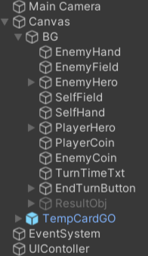
У каждого обьекта есть своя графическа интопретация
Обьекты связаны со скриптами написанные на C#, которые реализуют логику работы обьектов.
Связи обьектов со скриптами и их графическая интопретация:
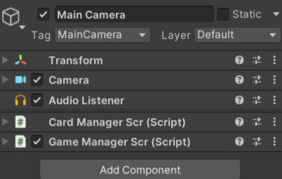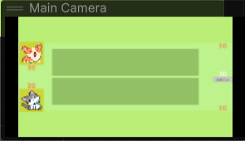
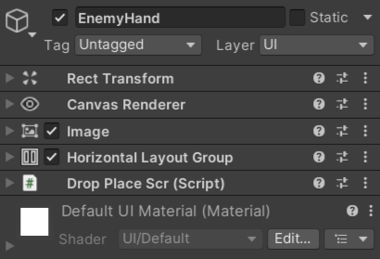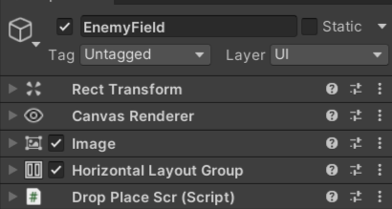
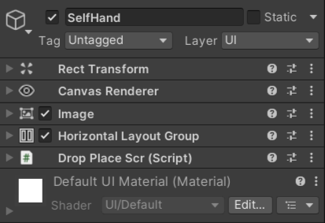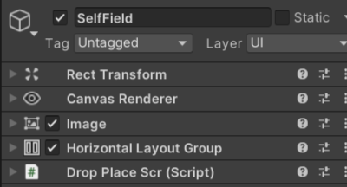
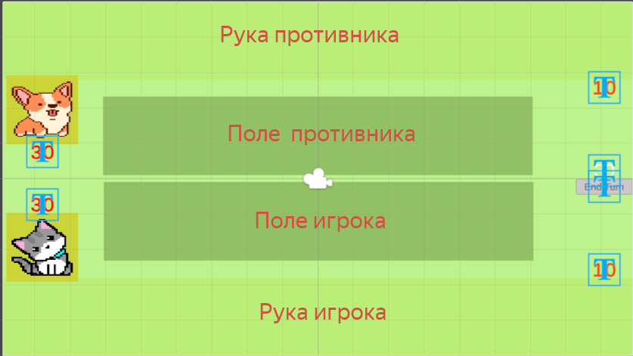
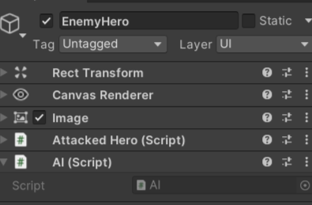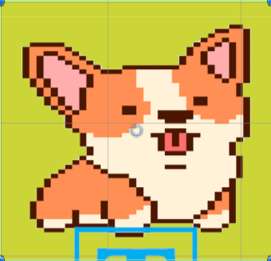
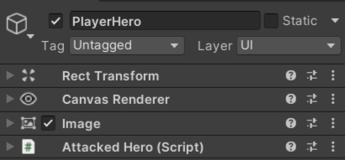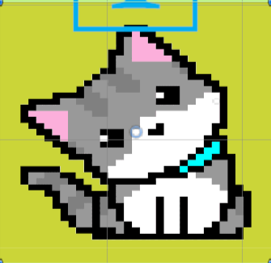
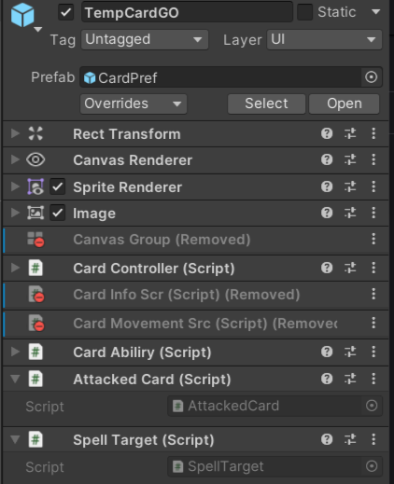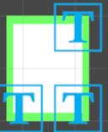
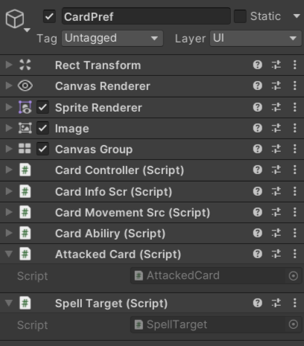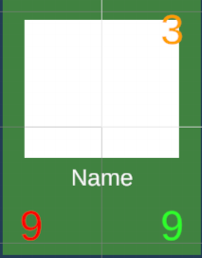

Скрипты:
AI – скрипт отвечающий за противника
AttackedCard - скрипт отвечающий за возможность атаковать карты
AttackedHero – скрипт срабатывающий когда игрок атакует героя картой
CardAbiliry – скрипт обрабатывающий способности карт
CardController – скрипт отвечающий за работу карт
CardInfoScr – скрипт управляющий вненшним видом карт
CardManagerScr – управление картами
DropPlaceScr – скрипт отвечающий за поля на которые можно перемещать карту
CardMovementScr – скрипт управляющий движение карт
GameManagerScr – скрипт отвечающий за игровой процесс
Player – скрипт о игроках
SpellTarget – скрипт цели заклинаний
UIController – скрипт для работы с пользовательским интерфейсом

AI:
using System.Collections;
using System.Collections.Generic;
using System.Security.Cryptography;
using UnityEngine;
using UnityEngine.UIElements;

public class AI : MonoBehaviour
{
public void MakeTurn()
{
StartCoroutine(EnemyTurn(GameManagerScr.Instance.EnemyHandCards));
}

IEnumerator EnemyTurn(List<CardController> cards)
{
yield return new WaitForSeconds(1);

int count = cards.Count == 1 ? 1 :
Random.Range(0, cards.Count);

for (int i = 0; i < count; i++)
{
if (GameManagerScr.Instance.EnemyFieldCards.Count > 5
|| GameManagerScr.Instance.CurrentGame.Enemy.Coin == 0
|| GameManagerScr.Instance.EnemyHandCards.Count == 0)
break; //Ограничение количества карт на поле

List<CardController> cardsList = cards.FindAll(x => GameManagerScr.Instance.CurrentGame.Enemy.Coin >= x.Card.Cost);

if (cardsList.Count == 0) break;

if (cardsList[0].Card.IsSpell)
{
CastSpell(cardsList[0]);
yield return new WaitForSeconds(.51f);
}
else
{
cardsList[0].GetComponent<CardMovementSrc>().MoveToField(GameManagerScr.Instance.EnemyField);
yield return new WaitForSeconds(.51f);
cardsList[0].transform.SetParent(GameManagerScr.Instance.EnemyField);
cardsList[0].OnCast();
}
}

yield return new WaitForSeconds(1);

while (GameManagerScr.Instance.EnemyFieldCards.Exists(x => x.Card.CanAttack))
{
var activeCard = GameManagerScr.Instance.EnemyFieldCards.FindAll(x => x.Card.CanAttack)[0];
bool hasProvocation = GameManagerScr.Instance.PlayerFieldCards.Exists(x => x.Card.IsProvocation);

if (hasProvocation ||
Random.Range(0, 2) == 0 && GameManagerScr.Instance.PlayerFieldCards.Count > 0)
{
CardController enemy;

if (hasProvocation)
enemy = GameManagerScr.Instance.PlayerFieldCards.Find(x => x.Card.IsProvocation);
else enemy = GameManagerScr.Instance.PlayerFieldCards[Random.Range(0, GameManagerScr.Instance.PlayerFieldCards.Count)];

Debug.Log(activeCard.Card.Name + " (" + activeCard.Card.Attack + ";" + activeCard.Card.Defense + ")" + "---> " +
enemy.Card.Name + " (" + enemy.Card.Attack + ";" + enemy.Card.Defense + ")");

activeCard.Movement.MoveToTarget(enemy.transform);
yield return new WaitForSeconds(.75f);

GameManagerScr.Instance.CardFight(enemy, activeCard);
}
else
{
Debug.Log(activeCard.Card.Name + " (" + activeCard.Card.Attack + ") Attacked hero");

activeCard.Movement.MoveToTarget(GameManagerScr.Instance.PlayerHero.transform);
yield return new WaitForSeconds(.75f);

GameManagerScr.Instance.DamageHero(activeCard, false);
}

yield return new WaitForSeconds(.2f);
}

yield return new WaitForSeconds(1);
GameManagerScr.Instance.ChangeTurn();
}

void CastSpell(CardController card)
{
switch (((SpellCard)card.Card).SpellTarget)
{
case SpellCard.TargetType.NO_TARGET:

switch (((SpellCard)card.Card).Spell)
{
case SpellCard.SpellType.HEAL_ALLY_FIELD_CARDS:

if (GameManagerScr.Instance.EnemyFieldCards.Count>0)
StartCoroutine(CastCard(card));

break;

case SpellCard.SpellType.DAMAGE_ENEMY_FIELD_CARDS:

if (GameManagerScr.Instance.PlayerFieldCards.Count > 0)
StartCoroutine(CastCard(card));

break;

case SpellCard.SpellType.HEAL_ALLY_CARD:
StartCoroutine(CastCard(card));
break;

case SpellCard.SpellType.DAMAGE_ENEMY_CARD:
StartCoroutine(CastCard(card));
break;
}
break;

case SpellCard.TargetType.ALLY_CARD_TARGET:

if (GameManagerScr.Instance.EnemyFieldCards.Count > 0)
StartCoroutine(CastCard(card, GameManagerScr.Instance.EnemyFieldCards[Random.Range(0, GameManagerScr.Instance.EnemyFieldCards.Count)]));

break;

case SpellCard.TargetType.ENEMY_CARD_TARGET:

if(GameManagerScr.Instance.PlayerFieldCards.Count > 0)
StartCoroutine(CastCard(card, GameManagerScr.Instance.PlayerFieldCards[Random.Range(0, GameManagerScr.Instance.PlayerFieldCards.Count)]));

break;
}

}

IEnumerator CastCard(CardController spell,CardController target=null)
{
if (((SpellCard)spell.Card).SpellTarget == SpellCard.TargetType.NO_TARGET)
{
spell.GetComponent<CardMovementSrc>().MoveToField(GameManagerScr.Instance.EnemyField);
yield return new WaitForSeconds(.51f);

spell.OnCast();
}
else
{
spell.Info.ShowCardInfo();
spell.GetComponent<CardMovementSrc>().MoveToTarget(target.transform);
yield return new WaitForSeconds(.51f);

GameManagerScr.Instance.EnemyHandCards.Remove(spell);
GameManagerScr.Instance.EnemyFieldCards.Add(spell);
GameManagerScr.Instance.ReduceCoin(false, spell.Card.Cost);

spell.Card.IsPlaced = true;

spell.UseSpell(target);
}

string targetStr=target==null ?"no_target":target.Card.Name;
Debug.Log("AI spell cast: "+(spell.Card).Name+" target: "+targetStr);
}

}

AttackedCard:
using System.Collections;
using System.Collections.Generic;
using Unity.VisualScripting;
using UnityEngine;
using UnityEngine.EventSystems;

public class AttackedCard : MonoBehaviour,IDropHandler
{
public void OnDrop(PointerEventData eventData)
{
if (!GameManagerScr.Instance.IsPlayerTurn) { return; }

CardController attacker = eventData.pointerDrag.GetComponent<CardController>(),
defender=GetComponent<CardController>();

if(attacker &&
attacker.Card.CanAttack &&
defender.Card.IsPlaced)
{
if (GameManagerScr.Instance.EnemyFieldCards.Exists(x => x.Card.IsProvocation) &&
!defender.Card.IsProvocation)
return;

GameManagerScr.Instance.CardFight(attacker,defender);
}
}
}

AttackedHero:
using System.Collections;
using System.Collections.Generic;
using UnityEngine;
using UnityEngine.EventSystems;
using UnityEngine.UI;

public class AttackedHero : MonoBehaviour, IDropHandler
{
public enum HeroType
{
ENEMY,
PLAYER
}

public HeroType type;
public Color NormalColor, TargetColor;

public void OnDrop(PointerEventData eventData)
{
if (!GameManagerScr.Instance.IsPlayerTurn)
return;

CardController card=eventData.pointerDrag.GetComponent<CardController>();

if(card &&
card.Card.CanAttack &&
type== HeroType.ENEMY &&
!GameManagerScr.Instance.EnemyFieldCards.Exists(x=>x.Card.IsProvocation))
{
GameManagerScr.Instance.DamageHero(card,true);
}
}

public void HighlightAsTarget(bool highlight)
{
GetComponent<Image>().color = highlight ? TargetColor : NormalColor;

}

}

CardAbiliry:
using UnityEngine;

public class CardAbiliry : MonoBehaviour
{
public CardController CC;

public GameObject Shield, Provocation;

public void OnCast()
{
foreach (var ability in CC.Card.Abilities)
{
switch (ability)
{
case Card.AbilityType.INSTANT_ACTIVE:
CC.Card.CanAttack = true;

if(CC.IsPlayerCard)
{
CC.Info.HighlightCard(true);
}

break;
case Card.AbilityType.SHIELD:
Shield.SetActive(true);
break;
case Card.AbilityType.PROVOCATION:
Provocation.SetActive(true);
break;
}
}

}

public void OnDamageDeal()
{
foreach(var ability in CC.Card.Abilities)
{
switch (ability)
{
case Card.AbilityType.DOUBLE_ATTACK:

if(CC.Card.TimesDealDamage==1)
{
CC.Card.CanAttack=true;

if(CC.IsPlayerCard)
{
CC.Info.HighlightCard(true);
}
}
break;
}
}
}

public void OnTakeDamage(CardController attacker = null)
{
Shield.SetActive(false);

foreach(var ability in CC.Card.Abilities)
{
switch (ability)
{
case Card.AbilityType.SHIELD:
Shield.SetActive(true);
break;
case Card.AbilityType.COUNTER_ATTACK:

if (attacker != null)
attacker.Card.GetDamage(CC.Card.Attack);

break;
}
}
}

public void OnNewTurn()
{
CC.Card.TimesDealDamage = 0;

foreach(var ability in CC.Card.Abilities)
{
switch (ability)
{
case Card.AbilityType.REGENERATION_EACH_TURN:
CC.Card.Defense += 2;
CC.Info.RefreshData();
break;
}
}
}
}

CardController:
using System.Collections;
using System.Collections.Generic;
using Unity.VisualScripting;
using UnityEngine;

public class CardController : MonoBehaviour
{
public Card Card;

public bool IsPlayerCard;

public CardInfoScr Info;
public CardMovementSrc Movement;
public CardAbiliry Ability;

GameManagerScr gameManager;

public void Init(Card card,bool isPlayerCard)
{
Card = card;
gameManager=GameManagerScr.Instance;
IsPlayerCard = isPlayerCard;

if(isPlayerCard)
{
Info.ShowCardInfo();
GetComponent<AttackedCard>().enabled = false;
}
else
{

Info.HideCardInfo();
}

}

public void OnCast()
{
if (Card.IsSpell && ((SpellCard)Card).SpellTarget != SpellCard.TargetType.NO_TARGET)
return;

if(IsPlayerCard)
{
gameManager.PlayerHandCards.Remove(this);
gameManager.PlayerFieldCards.Add(this);
gameManager.ReduceCoin(true, Card.Cost);
gameManager.CheckCardsForCoinAvaliability();
}
else
{
gameManager.EnemyHandCards.Remove(this);
gameManager.EnemyFieldCards.Add(this);
gameManager.ReduceCoin(false, Card.Cost);
Info.ShowCardInfo();
}

Card.IsPlaced = true;

if (Card.HasAbility)
Ability.OnCast();

if (Card.IsSpell)
UseSpell(null);

UIControllerScr.Instance.UpdateHPandCoin();
}

public void OnTakeDamage(CardController attacker=null)
{
CheckForAllive();
Ability.OnTakeDamage(attacker);
}

public void OnDamageDeal()
{
Card.TimesDealDamage++;
Card.CanAttack = false;
Info.HighlightCard(false);

if(Card.HasAbility)
Ability.OnDamageDeal();
}

public void UseSpell(CardController target)
{
var spellCard = (SpellCard)Card;

switch (spellCard.Spell)
{
case SpellCard.SpellType.DEBUFF_CARD_DAMAGE:
target.Card.Attack = Mathf.Clamp(target.Card.Attack - spellCard.SpellValue, 0, int.MaxValue);
break;

case SpellCard.SpellType.BUFF_CARD_DAMAGE:
target.Card.Attack += spellCard.SpellValue;
break;

case SpellCard.SpellType.DAMAGE_ENEMY_CARD:
GiveDamageTo(target, spellCard.SpellValue);
break;

case SpellCard.SpellType.SHIELD_ON_ALLY_CARD:
if (!target.Card.Abilities.Exists(x => x == Card.AbilityType.SHIELD))
target.Card.Abilities.Add(Card.AbilityType.SHIELD);
break;

case SpellCard.SpellType.DAMAGE_ENEMY_FIELD_CARDS:

var enemyCards = IsPlayerCard ? new List<CardController>(gameManager.EnemyFieldCards) :
new List<CardController>(gameManager.PlayerFieldCards);

foreach (var card in enemyCards)
GiveDamageTo(card, spellCard.SpellValue);

break;

case SpellCard.SpellType.PROVOCATION_ON_ALLY_CARD:
if (!target.Card.Abilities.Exists(x => x == Card.AbilityType.PROVOCATION))
target.Card.Abilities.Add(Card.AbilityType.PROVOCATION);
break;

case SpellCard.SpellType.DAMAGE_ENEMY_HERO:

if (IsPlayerCard)
gameManager.CurrentGame.Enemy.HP -= spellCard.SpellValue;
else
gameManager.CurrentGame.Player.HP -= spellCard.SpellValue;

UIControllerScr.Instance.UpdateHPandCoin();
gameManager.CheckForResult();

break;

case SpellCard.SpellType.HEAL_ALLY_CARD:
target.Card.Defense += spellCard.SpellValue;
break;

case SpellCard.SpellType.HEAL_ALLY_FIELD_CARDS:

var allyCards = IsPlayerCard ? gameManager.PlayerFieldCards : gameManager.EnemyFieldCards;

foreach (var card in allyCards)
{
card.Card.Defense += spellCard.SpellValue;
card.Info.RefreshData();
}

break;

case SpellCard.SpellType.HEAL_ALLY_HERO:

if (IsPlayerCard)
gameManager.CurrentGame.Player.HP += spellCard.SpellValue;
else
gameManager.CurrentGame.Enemy.HP += spellCard.SpellValue;

UIControllerScr.Instance.UpdateHPandCoin();

break;
}

if (target !=null)
{
target.Ability.OnCast();
target.CheckForAllive();
}
DestroyCard();
}

void GiveDamageTo(CardController card,int damage)
{
card.Card.GetDamage(damage);
card.CheckForAllive();
card.OnTakeDamage();
}

public void CheckForAllive()
{
if (Card.IsAlive)
{
Info.RefreshData();
}
else { DestroyCard(); }
}

private void DestroyCard( )
{
Movement.OnEndDrag(null);

RemoveCardFromList(gameManager.EnemyFieldCards);
RemoveCardFromList(gameManager.EnemyHandCards);
RemoveCardFromList(gameManager.PlayerFieldCards);
RemoveCardFromList(gameManager.PlayerHandCards);

Destroy(gameObject);
}

void RemoveCardFromList(List<CardController> list)
{
if(list.Exists(x => x==this) )
list.Remove(this);
}

}

CardInfoScr:
using System.Collections;
using System.Collections.Generic;
using UnityEngine;
using UnityEngine.UI;
using TMPro;

public class CardInfoScr : MonoBehaviour
{
public CardController CC;

public Image Logo;
public TextMeshProUGUI Name,Attack,Defense,Cost;
public GameObject HideObj,HighlitedObj;
public Color NormalColor, TargetColor, SpellTargetColor;

public void HideCardInfo()
{
HideObj.SetActive(true);
Cost.text = "";
}

public void ShowCardInfo()
{

HideObj.SetActive(false);

Logo.sprite = CC.Card.Logo;
Logo.preserveAspect = true;
Name.text = CC.Card.Name;

if(CC.Card.IsSpell)
{
Attack.gameObject.SetActive(false);
Defense.gameObject.SetActive(false);
}

RefreshData();

}

public void RefreshData()
{
Attack.text = CC.Card.Attack.ToString();
Defense.text = CC.Card.Defense.ToString();
Cost.text= CC.Card.Cost.ToString();
}

public void HighlightCard(bool highlight)
{
HighlitedObj.SetActive(highlight);
}

public void CheckCoinAvailability(int currentCoin)
{
GetComponent<CanvasGroup>().alpha = currentCoin >= CC.Card.Cost ? 1 : .5f;
}

public void HighlightAsTarget(bool highlight)
{
GetComponent<Image>().color = highlight ? TargetColor : NormalColor;

}

public void HighlightAsSpellTarget(bool highlight)
{
GetComponent<Image>().color = highlight ? SpellTargetColor : NormalColor;

}

}

CardManagerScr:
using System.Collections;
using System.Collections.Generic;
using UnityEngine;

public class Card
{
public enum AbilityType
{
NO_ABILITY,
INSTANT_ACTIVE,
DOUBLE_ATTACK,
SHIELD,
PROVOCATION,
REGENERATION_EACH_TURN,
COUNTER_ATTACK
}

public string Name;
public Sprite Logo;
public int Attack, Defense,Cost;
public bool CanAttack;
public bool IsPlaced;

public List<AbilityType> Abilities;

public bool HasAbility
{
get
{
return Abilities.Count > 0;
}
}

public bool IsProvocation
{
get
{
return Abilities.Exists(x => x == AbilityType.PROVOCATION);
}
}

public bool IsAlive
{
get
{
return Defense > 0;
}
}

public bool IsSpell;

public int TimesDealDamage;

public Card(string name,string logoPath,int attack,int defense,int cost,AbilityType abilityType=0)
{
Name = name;
Logo=Resources.Load<Sprite>(logoPath);
Attack = attack; Defense = defense; Cost = cost;
CanAttack = false;
IsPlaced = false;

Abilities = new List<AbilityType>();

if(abilityType!=0)
Abilities.Add(abilityType);

TimesDealDamage = 0;
}

public Card(Card card)
{
Name = card.Name; Logo=card.Logo; Attack = card.Attack; Defense = card.Defense; Cost = card.Cost;CanAttack=false; IsPlaced = false;
Abilities = new List<AbilityType>(card.Abilities);
TimesDealDamage = 0;
}

public void GetDamage(int damage)
{
if (damage > 0)
{
if(Abilities.Exists(x=>x==AbilityType.SHIELD))
Abilities.Remove(AbilityType.SHIELD);
else
Defense -= damage;
}
}

public Card GetCopy()
{
return new Card(this);
}
}

public class SpellCard : Card
{
public enum SpellType
{
NO_SPELL,
HEAL_ALLY_FIELD_CARDS,
HEAL_ALLY_HERO,
DAMAGE_ENEMY_FIELD_CARDS,
DAMAGE_ENEMY_HERO,
HEAL_ALLY_CARD,
DAMAGE_ENEMY_CARD,
SHIELD_ON_ALLY_CARD,
PROVOCATION_ON_ALLY_CARD,
BUFF_CARD_DAMAGE,
DEBUFF_CARD_DAMAGE
}

public enum TargetType
{
NO_TARGET,
ALLY_CARD_TARGET,
ENEMY_CARD_TARGET
}

public SpellType Spell;
public TargetType SpellTarget;
public int SpellValue;

public SpellCard(string name,string logoPath,int cost,SpellType spellType=0,int spellValue=0,TargetType targetType=0):base(name,logoPath,0,0,cost)
{
IsSpell=true;

Spell=spellType;
SpellTarget=targetType;
SpellValue=spellValue;
}

public SpellCard(SpellCard card) : base (card)
{
IsSpell = true;

Spell =card.Spell;
SpellTarget = card.SpellTarget;
SpellValue = card.SpellValue;
}

public new SpellCard GetCopy()
{
return new SpellCard(this);
}

}

public static class CardManager
{
public static List<Card> AllCards=new List<Card>();
}

public class CardManagerScr : MonoBehaviour
{
public void Awake()
{
CardManager.AllCards.Add(new Card("Black cat", "Sprite/Cards/black_cat",2,1,1));
CardManager.AllCards.Add(new Card("Ginger cat", "Sprite/Cards/ginger_cat", 1, 2,1));
CardManager.AllCards.Add(new Card("Dog", "Sprite/Cards/dog", 3, 3,2));
CardManager.AllCards.Add(new Card("Horse", "Sprite/Cards/horse", 5, 4, 3));
CardManager.AllCards.Add(new Card("Snake", "Sprite/Cards/snake", 1, 1, 1));
CardManager.AllCards.Add(new Card("Magic horse", "Sprite/Cards/unicorn_horse", 7, 5,5));
CardManager.AllCards.Add(new Card("Lion", "Sprite/Cards/lion", 7, 7, 7));
CardManager.AllCards.Add(new Card("Turtle", "Sprite/Cards/turtle", 4, 8,5));
CardManager.AllCards.Add(new Card("Panda", "Sprite/Cards/panda", 5, 9, 7));

CardManager.AllCards.Add(new Card("Provocation", "Sprite/Cards/Provocation", 3, 6, 3,Card.AbilityType.PROVOCATION));
CardManager.AllCards.Add(new Card("Regeneration", "Sprite/Cards/Regeneration", 4, 3, 4,Card.AbilityType.REGENERATION_EACH_TURN));
CardManager.AllCards.Add(new Card("DoubleAttack", "Sprite/Cards/DoubleAttack", 3, 5, 3,Card.AbilityType.DOUBLE_ATTACK));
CardManager.AllCards.Add(new Card("InstantActive", "Sprite/Cards/InstantAttack", 4, 2, 2,Card.AbilityType.INSTANT_ACTIVE));
CardManager.AllCards.Add(new Card("Shield", "Sprite/Cards/Shield", 4, 8, 6,Card.AbilityType.SHIELD));
CardManager.AllCards.Add(new Card("CounterAttack", "Sprite/Cards/CounterAttack", 6, 10, 8,Card.AbilityType.COUNTER_ATTACK));

CardManager.AllCards.Add(new SpellCard("HEAL ALLY FIELD CARDS", "Sprite/Cards/healAllyCards", Random.Range(1, 5), SpellCard.SpellType.HEAL_ALLY_FIELD_CARDS, Random.Range(1,3),
SpellCard.TargetType.NO_TARGET));
CardManager.AllCards.Add(new SpellCard("DAMAGE ENEMY FIELD CARD", "Sprite/Cards/damageEnemyCards", Random.Range(1, 3), SpellCard.SpellType.DAMAGE_ENEMY_FIELD_CARDS, Random.Range(1,2),
SpellCard.TargetType.NO_TARGET));
CardManager.AllCards.Add(new SpellCard("HEAL ALLY HERO", "Sprite/Cards/healAllyHero", Random.Range(1, 5), SpellCard.SpellType.HEAL_ALLY_HERO, Random.Range(1, 3),
SpellCard.TargetType.NO_TARGET));
CardManager.AllCards.Add(new SpellCard("DAMAGE ENEMY HERO", "Sprite/Cards/damageEnemyHero", Random.Range(1, 5), SpellCard.SpellType.DAMAGE_ENEMY_HERO,Random.Range(1, 3),
SpellCard.TargetType.NO_TARGET));
CardManager.AllCards.Add(new SpellCard("HEAL ALLY CARD", "Sprite/Cards/healAllyCard", Random.Range(3, 7), SpellCard.SpellType.HEAL_ALLY_CARD, Random.Range(1, 3),
SpellCard.TargetType.ALLY_CARD_TARGET));
CardManager.AllCards.Add(new SpellCard("DAMAGE ENEMY CARD", "Sprite/Cards/damageEnemyCard", Random.Range(3, 5), SpellCard.SpellType.DAMAGE_ENEMY_CARD, Random.Range(1, 3),
SpellCard.TargetType.ENEMY_CARD_TARGET));
CardManager.AllCards.Add(new SpellCard("SHIELD ON ALLY CARD", "Sprite/Cards/shieldOnAllyCard", 2, SpellCard.SpellType.SHIELD_ON_ALLY_CARD, 2,
SpellCard.TargetType.ALLY_CARD_TARGET));
CardManager.AllCards.Add(new SpellCard("PROVOCATION ON ALLY CARD", "Sprite/Cards/provocationOnAllyCard", 2, SpellCard.SpellType.PROVOCATION_ON_ALLY_CARD, 2,
SpellCard.TargetType.ALLY_CARD_TARGET));
CardManager.AllCards.Add(new SpellCard("BUFF CARD DAMAGE", "Sprite/Cards/buffCardDamage", Random.Range(1, 3), SpellCard.SpellType.BUFF_CARD_DAMAGE, 2,
SpellCard.TargetType.ALLY_CARD_TARGET));
CardManager.AllCards.Add(new SpellCard("DEBUFF CARD DAMAGE", "Sprite/Cards/debuffCardDamage", Random.Range(1,3), SpellCard.SpellType.DEBUFF_CARD_DAMAGE, 2,
SpellCard.TargetType.ENEMY_CARD_TARGET));

}

}

CardMovementScr:
using System.Collections;
using System.Collections.Generic;
using UnityEngine;
using UnityEngine.EventSystems;
using DG.Tweening;
using UnityEngine.UI;

public class CardMovementSrc : MonoBehaviour, IBeginDragHandler, IDragHandler,IEndDragHandler
{
public CardController CC;

Camera MainCamera;
Vector3 offset;
public Transform DefaultParent,DefaultTempCardParent;
GameObject TempCardGO;
public bool isDraggable;
int startId;

void Awake()
{
MainCamera = Camera.allCameras[0];
TempCardGO = GameObject.Find("TempCardGO");
}

public void OnBeginDrag(PointerEventData eventData)
{
offset = transform.position - MainCamera.ScreenToWorldPoint(eventData.position);
DefaultParent =DefaultTempCardParent= transform.parent;

isDraggable = GameManagerScr.Instance.IsPlayerTurn &&
(
(DefaultParent.GetComponent<DropPlaceScr>().Type==FieldType.SELF_HAND &&
GameManagerScr.Instance.CurrentGame.Player.Coin >= CC.Card.Cost) ||
(DefaultParent.GetComponent<DropPlaceScr>().Type==FieldType.SELF_FIELD &&
CC.Card.CanAttack)

);

if(!isDraggable)
{
return;
}

startId = transform.GetSiblingIndex();

if (CC.Card.IsSpell || CC.Card.CanAttack)
GameManagerScr.Instance.HighlightTargets(CC,true);

TempCardGO.transform.SetParent(DefaultParent);
TempCardGO.transform.SetSiblingIndex(transform.GetSiblingIndex());

transform.SetParent(DefaultParent.parent);
GetComponent<CanvasGroup>().blocksRaycasts = false;
}

public void OnDrag(PointerEventData eventData)
{

if (!isDraggable)
{
return;
}

Vector3 newPos=MainCamera.ScreenToWorldPoint(eventData.position);
transform.position = newPos+offset;

if (!CC.Card.IsSpell)
{
if (TempCardGO.transform.parent != DefaultTempCardParent)
TempCardGO.transform.SetParent(DefaultTempCardParent);

if (DefaultTempCardParent.GetComponent<DropPlaceScr>().Type != FieldType.SELF_FIELD)
CheckPosiotion();
}
}

public void OnEndDrag(PointerEventData eventData)
{

if (!isDraggable)
{
return;
}

GameManagerScr.Instance.HighlightTargets(CC,false);

transform.SetParent(DefaultParent);
GetComponent<CanvasGroup>().blocksRaycasts = true;

transform.SetSiblingIndex(TempCardGO.transform.GetSiblingIndex());
TempCardGO.transform.SetParent(GameObject.Find("Canvas").transform);
TempCardGO.transform.localPosition = new Vector3(2740, 0);
}

void CheckPosiotion()
{
int newIndex = DefaultTempCardParent.childCount;

for(int i = 0; i < DefaultTempCardParent.childCount; i++)
{

if (transform.position.x < DefaultTempCardParent.GetChild(i).position.x)
{
newIndex = i;

if (TempCardGO.transform.GetSiblingIndex() < newIndex)
{
newIndex--;
}

break;
}
}

if (TempCardGO.transform.parent == DefaultParent)
newIndex = startId;

TempCardGO.transform.SetSiblingIndex(newIndex);

}

public void MoveToField(Transform field)
{
transform.SetParent(GameObject.Find("Canvas").transform);
transform.DOMove(field.position, .5f);
}

public void MoveToTarget(Transform target)
{
StartCoroutine(MoveToTargetCor(target));
}

IEnumerator MoveToTargetCor(Transform target)
{
Vector3 pos= transform.position;
Transform parent=transform.parent;
int index=transform.GetSiblingIndex();

if(transform.parent.GetComponent<HorizontalLayoutGroup>())
transform.parent.GetComponent<HorizontalLayoutGroup>().enabled=false;

transform.SetParent(GameObject.Find("Canvas").transform);

transform.DOMove(target.position,.25f);

yield return new WaitForSeconds(.25f);

transform.DOMove(pos, .25f);

yield return new WaitForSeconds(.25f);

transform.SetParent(parent);
transform.SetSiblingIndex(index);

if(transform.parent.GetComponent<HorizontalLayoutGroup>())
transform.parent.GetComponent<HorizontalLayoutGroup>().enabled = true;
}

}

DropPlaceScr:
using System.Collections;
using System.Collections.Generic;
using UnityEngine;
using UnityEngine.EventSystems;

public enum FieldType
{
SELF_HAND,
SELF_FIELD,
ENEMY_HAND,
ENEMY_FIELD,
}

public class DropPlaceScr : MonoBehaviour, IDropHandler,IPointerEnterHandler,IPointerExitHandler
{
public FieldType Type;

public void OnDrop(PointerEventData eventData)
{
if (Type != FieldType.SELF_FIELD)
{ return; }

CardController card = eventData.pointerDrag.GetComponent<CardController>();

if (card && GameManagerScr.Instance.IsPlayerTurn &&
GameManagerScr.Instance.CurrentGame.Player.Coin>=card.Card.Cost &&
!card.Card.IsPlaced)
{
if(!card.Card.IsSpell) { }
card.Movement.DefaultParent = transform;

card.OnCast();

}
}

public void OnPointerEnter(PointerEventData eventData)
{
if (eventData.pointerDrag == null || Type==FieldType.ENEMY_FIELD || Type==FieldType.ENEMY_HAND || Type==FieldType.SELF_HAND)
return;

CardMovementSrc card = eventData.pointerDrag.GetComponent<CardMovementSrc>();

if(card)
card.DefaultTempCardParent = transform;
}

public void OnPointerExit(PointerEventData eventData)
{
if (eventData.pointerDrag == null)
return;

CardMovementSrc card = eventData.pointerDrag.GetComponent<CardMovementSrc>();

if (card && card.DefaultTempCardParent==transform)
card.DefaultTempCardParent = card.DefaultParent;
}
}

GameManagerScr:
using System.Collections;
using System.Collections.Generic;
using UnityEngine;
using UnityEngine.UI;
using TMPro;
using Unity.VisualScripting;

public class Game
{
public Player Player, Enemy;
public List<Card> EnemyDeck, PlayerDeck;

public Game()
{
EnemyDeck = GiveDeckCard();
PlayerDeck = GiveDeckCard();

Player=new Player();
Enemy=new Player();

}

List<Card> GiveDeckCard()
{
List<Card> list = new List<Card>();

list.Add(CardManager.AllCards[6].GetCopy());

for (int i = 0; i < 20; i++)
{
var card = CardManager.AllCards[Random.Range(0, CardManager.AllCards.Count)];

if (card.IsSpell)
list.Add(((SpellCard)card).GetCopy());
else list.Add(card.GetCopy());

}
return list;
}
}

public class GameManagerScr : MonoBehaviour
{
public static GameManagerScr Instance;

public Game CurrentGame;
public Transform EnemyHand, PlayerHand,
EnemyField,PalyerField;
public GameObject CardPref;
int Turn, TurnTime = 30;

public AttackedHero EnemyHero, PlayerHero;
public AI EnemyAI;

public List<CardController> PlayerHandCards = new List<CardController>(),
PlayerFieldCards = new List<CardController>(),
EnemyHandCards = new List<CardController>(),
EnemyFieldCards = new List<CardController>();

public TextMeshProUGUI PlayerCoinTxt, EnemyCoinTxt;

public bool IsPlayerTurn
{
get
{
return Turn % 2 == 0;
}
}

public void Awake()
{
if (Instance == null)
Instance = this;
}

void Start()
{
StartGame();
}

public void RestartGame()
{
StopAllCoroutines();

foreach (var card in PlayerHandCards)
Destroy(card.gameObject);
foreach (var card in PlayerFieldCards)
Destroy(card.gameObject);

foreach (var card in EnemyHandCards)
Destroy(card.gameObject);
foreach (var card in EnemyFieldCards)
Destroy(card.gameObject);

PlayerHandCards.Clear(); EnemyHandCards.Clear();
PlayerFieldCards.Clear(); EnemyFieldCards.Clear();

StartGame();
}

void StartGame()
{
Turn = 0;

CurrentGame = new Game();

GiveHandCards(CurrentGame.EnemyDeck, EnemyHand);
GiveHandCards(CurrentGame.PlayerDeck, PlayerHand);

UIControllerScr.Instance.StartGame();

StartCoroutine(TurnFunc());
}

void GiveHandCards(List<Card> deck, Transform hand)
{
int i = 0;
while (i++ < 4)
GiveCardToHand(deck, hand);
}

void GiveCardToHand(List<Card> deck, Transform hand)
{
if (deck.Count == 0)
return;

CreateCardPref(deck[0],hand);

deck.RemoveAt(0);
}

void CreateCardPref(Card card,Transform hand)
{
GameObject cardGO = Instantiate(CardPref, hand, false);
CardController cardC=cardGO.GetComponent<CardController>();

cardC.Init(card, hand == PlayerHand);

if (cardC.IsPlayerCard)
PlayerHandCards.Add(cardC);
else
EnemyHandCards.Add(cardC);
}

IEnumerator TurnFunc()
{
TurnTime = 30;
UIControllerScr.Instance.UpdateTurnTime(TurnTime);

foreach(var card in PlayerFieldCards)
card.Info.HighlightCard(false);

CheckCardsForCoinAvaliability();

if (IsPlayerTurn)
{
foreach (var card in PlayerFieldCards)
{
card.Card.CanAttack = true;
card.Info.HighlightCard(true);
card.Ability.OnNewTurn();
}

while (TurnTime-- > 0)
{
UIControllerScr.Instance.UpdateTurnTime(TurnTime);
yield return new WaitForSeconds(1);
}

ChangeTurn();
}
else
{
foreach (var card in EnemyFieldCards)
{
card.Card.CanAttack = true;
card.Ability.OnNewTurn();
}

EnemyAI.MakeTurn();

while (TurnTime-- > 0)
{
UIControllerScr.Instance.UpdateTurnTime(TurnTime);
yield return new WaitForSeconds(1);
}

ChangeTurn();
}
}

public void ChangeTurn()
{
StopAllCoroutines();
Turn++;

UIControllerScr.Instance.DisableTurnButton();

if (IsPlayerTurn)
{
GiveNewCards();

CurrentGame.Player.IncreaseCoinpool();
CurrentGame.Player.RestoreRoundCoin();

UIControllerScr.Instance.UpdateHPandCoin();
}
else
{
CurrentGame.Enemy.IncreaseCoinpool();
CurrentGame.Enemy.RestoreRoundCoin();
}

StartCoroutine(TurnFunc());
}

void GiveNewCards()
{
GiveCardToHand(CurrentGame.EnemyDeck, EnemyHand);
GiveCardToHand(CurrentGame.PlayerDeck, PlayerHand);
}

public void CardFight(CardController attacker, CardController defender)
{
defender.Card.GetDamage(attacker.Card.Attack);
attacker.OnDamageDeal();
defender.OnTakeDamage(attacker);

attacker.Card.GetDamage(defender.Card.Attack);
attacker.OnTakeDamage();

attacker.CheckForAllive();
defender.CheckForAllive();

}

public void ReduceCoin(bool playerCoin,int costcoin)
{
if(playerCoin)
CurrentGame.Player.Coin -= costcoin;
else
CurrentGame.Enemy.Coin -= costcoin;

UIControllerScr.Instance.UpdateHPandCoin();
}

public void DamageHero(CardController card,bool isEnemyAttacked)
{
if (isEnemyAttacked)
CurrentGame.Enemy.GetDamage(card.Card.Attack);
else
CurrentGame.Player.GetDamage(card.Card.Attack);

UIControllerScr.Instance.UpdateHPandCoin();

card.OnDamageDeal();
CheckForResult();
}

public void CheckForResult()
{
if (CurrentGame.Enemy.HP == 0 || CurrentGame.Player.HP == 0)
{
StopAllCoroutines();
UIControllerScr.Instance.ShowResult();
}
}

public void CheckCardsForCoinAvaliability()
{
foreach (var card in PlayerHandCards)
{
card.Info.CheckCoinAvailability(CurrentGame.Player.Coin);
}
}

public void HighlightTargets(CardController attacker,bool highlight)
{
List<CardController> targets=new List<CardController>();

if (attacker.Card.IsSpell)
{
var spellCard=(SpellCard)attacker.Card;

if (spellCard.SpellTarget == SpellCard.TargetType.NO_TARGET)
targets = new List<CardController>();
else if (spellCard.SpellTarget == SpellCard.TargetType.ALLY_CARD_TARGET)
targets = PlayerFieldCards;
else
targets = EnemyFieldCards;

}
else
{
if (EnemyFieldCards.Exists(x => x.Card.IsProvocation))
targets = EnemyFieldCards.FindAll(x => x.Card.IsProvocation);
else
{
targets = EnemyFieldCards;

EnemyHero.HighlightAsTarget(highlight);
}
}

foreach (var card in targets)
{
if(attacker.Card.IsSpell)
card.Info.HighlightAsSpellTarget(highlight);
else
card.Info.HighlightAsTarget(highlight);
}

}
}

Player:
using UnityEngine;

public class Player
{
public int HP, Coin,Coinpool;

const int MAX_COINPOOL=10;

public Player()
{
HP = 45;
Coin = Coinpool = 2;
}

public void RestoreRoundCoin()
{
Coin=Coinpool;
}

public void IncreaseCoinpool()
{
Coinpool=Mathf.Clamp(Coinpool+1,0,MAX_COINPOOL);
}

public void GetDamage(int damage)
{
HP=Mathf.Clamp(HP-damage,0,int.MaxValue);
}
}

SpellTarget:
using UnityEngine;

public class Player
{
public int HP, Coin,Coinpool;

const int MAX_COINPOOL=10;

public Player()
{
HP = 45;
Coin = Coinpool = 2;
}

public void RestoreRoundCoin()
{
Coin=Coinpool;
}

public void IncreaseCoinpool()
{
Coinpool=Mathf.Clamp(Coinpool+1,0,MAX_COINPOOL);
}

public void GetDamage(int damage)
{
HP=Mathf.Clamp(HP-damage,0,int.MaxValue);
}
}

UIControllerScr:
using System.Collections;
using System.Collections.Generic;
using UnityEngine;
using TMPro;
using UnityEngine.UI;

public class UIControllerScr : MonoBehaviour
{
public static UIControllerScr Instance;

public TextMeshProUGUI PlayerCoin, EnemyCoin;
public TextMeshProUGUI PlayerHP, EnemyHP;

public GameObject ResultGO;
public TextMeshProUGUI ResultTxt;

public TextMeshProUGUI TurnTime;
public Button EndTurnButton;

private void Awake()
{
if(!Instance)
Instance = this;
else
{
Destroy(gameObject);
return;
}

DontDestroyOnLoad(this);
}

public void StartGame()
{
EndTurnButton.interactable = true;
ResultGO.SetActive(false);
UpdateHPandCoin();
}

public void UpdateHPandCoin()
{
PlayerCoin.text=GameManagerScr.Instance.CurrentGame.Player.Coin.ToString();
EnemyCoin.text = GameManagerScr.Instance.CurrentGame.Enemy.Coin.ToString();
PlayerHP.text = GameManagerScr.Instance.CurrentGame.Player.HP.ToString();
EnemyHP.text = GameManagerScr.Instance.CurrentGame.Enemy.HP.ToString();
}

public void ShowResult()
{
ResultGO.SetActive(true);

if (GameManagerScr.Instance.CurrentGame.Enemy.HP == 0)
ResultTxt.text = "Win";
else
ResultTxt.text = "Lose";

}

public void UpdateTurnTime(int time)
{
TurnTime.text=time.ToString();
}

public void DisableTurnButton()
{
EndTurnButton.interactable = GameManagerScr.Instance.IsPlayerTurn;
}
}

Выводы: была реализована коллекционная карточная игра эволюция

